**Team Utkarsh- UVPCE**

**ROBOCON-2020**



**Controller Board   
Data sheet**

Prepared By:

**Nipun Bindal**

**(Electronics Coordinator 2020)**

**+91 98551-51388**

**Index**

|  |  |  |
| --- | --- | --- |
| **Sr. No.** | **Title** | **Page No.** |
|  | Pin-outs | 3 |
|  | Position Diagram | 5 |
|  | Power Supply | 6 |
|  | Proximity Sensors | 7 |
|  | Motor Drivers | 7 |
|  | DCV Switches | 8 |
|  | LSA-08 (Line Following Sensor) | 8 |
|  | Rotary Encoders | 9 |
|  | USB Host Shield | 9 |
|  | Micro SD-Card Adapter | 10 |
|  | 74157 MUX | 10 |
|  | FTDI Module | 11 |
|  | USART Socket | 12 |
|  | Stepper Driver | 12 |
|  | X-bee | 12 |
|  | I2C Socket | 12 |
|  | EEPROM IC24LC256 | 13 |
|  | LCD | 13 |
|  | Limit Switch | 13 |
|  | Servo | 13 |
|  | Testing Circuit | 14 |

1. **Pin-Outs**

|  |  |  |
| --- | --- | --- |
| **ITEM** | **PIN NUMBER** | **Position** |
| PROXIMITY-1 | PJ2 | 4A |
| PROXIMITY-2 | PJ3 | 4B |
| PROXIMITY-3 | PJ4 | 4C |
| PROXIMITY-4 | PJ5 | 4D |
| PROXIMITY-5 | PJ6 | 4E |
| PROXIMITY-6 | PK4 | 4F |
| PROXIMITY-7 | PK5 | 4G |
| PROXIMITY-8 | PK6 | 4H |
| PROXIMITY-9 | PK7 | 4I |
| CYTRON-1 | PWM1-PL5, DIR1-PL7, PWM2-PL4, DIR2-PL6 | 5A |
| CYTRON-2 | PWM1-PL3, DIR1-PL1, PWM2-PB7, DIR2-PB0 | 5B |
| CYTRON-3 | PWM1-PH4, DIR1-PG4, PWM2-PH3, DIR2-PG2 | 5C |
| CYTRON-4 | PWM1-PB5, DIR1-PH2, PWM2-PB6, DIR2-PG3 | 5D |
| ULN2003 (SET-1) HC | PA0 | 6A |
| ULN2003 (SET-2) HC | PA1 | 6B |
| ULN2003 (SET-3) LC | PA2 | 6C |
| ULN2003 (SET-4) LC | PA3 | 6D |
| ULN2003 (SET-5) LC | PA4 | 6E |
| ULN2003 (SET-6) LC | PA5 | 6F |
| LSA-08-1 | ANALOG-PF0, JUNCTION-PE7 | 7A |
| LSA-08-2 | ANALOG-PF1, JUNCTION-PE6 | 7B |
| LSA-08-3 | ANALOG-PF3, JUNCTION-PE4 | 7C |
| LSA-08-4 | ANALOG-PF2, JUNCTION-PD2 | 7D |
| LSA-08-5 | ANALOG-PF4, JUNCTION-PD3 | 7E |
| ROTARY ENCODER-1 | PE4,PE5 | 8A |
| ROTARY ENCODER-2 | PE7, PE6 | 8B |
| USB HOST SHIELD | PB4, RST, MISO, MOSI, SCK | 9A,9B,9C |
| MICRO SD CARD ADAPTER | MISO, MOSI, SCK, SS-PC7 | 10A |
| 74157 MUX | SELECT-PA7 | 11A,11B |
| FTDI MODULE | RX0-PE0, TX0-PE1, RST | 12A |
| USART PINS-1 | RX2-PH0, TX2-PH1 | 13A |
| USART PINS-2 | RX3-PJ0, TX3-PJ1 | 13B |
| STEPPER DRIVER | PC0, PG0, PG1 | 14A |
| XBEE | DOUT-PE0, DIN-PE1, RST | 15A |
| I2C PINS | SCL-PD0, SDA-PD1 | 16A,16B,16C |
| EEPROM IC24LC256 | SCL-PD0, SDA-PD1 | 17A |
| LCD | RS-PC6, E-PC5, D4-PC4, D5-PC3, D6-PC2, D7-PC1 | 18A,18B |
| LIMIT SWITCH-1 | PK1 | 19A |
| LIMIT SWITCH-2 | PK0 | 19B |
| LIMIT SWITCH-3 | PF7 | 19C |
| LIMIT SWITCH-4 | PF6 | 19D |
| LIMIT SWITCH-5 | PK2 | 19E |
| LIMIT SWITCH-6 | PK3 | 19F |
| SERVO-1 | PE3 | 20A |
| SERVO-2 | PH5 | 20B |
| SERVO-3 | PH6 | 20C |
| SERVO-4 | PG5 | 20D |
| TESTING CIRCUIT | GND | 21A |

**STANDARDS- MISO-PB3, MOSI-PB2, SCK-PB1

**Extra pins**- PD4, PD5, PD6, PD7, PA6, PJ7, PF5, PE2, PH7, PL0, PL2

1. **Position Diagram**

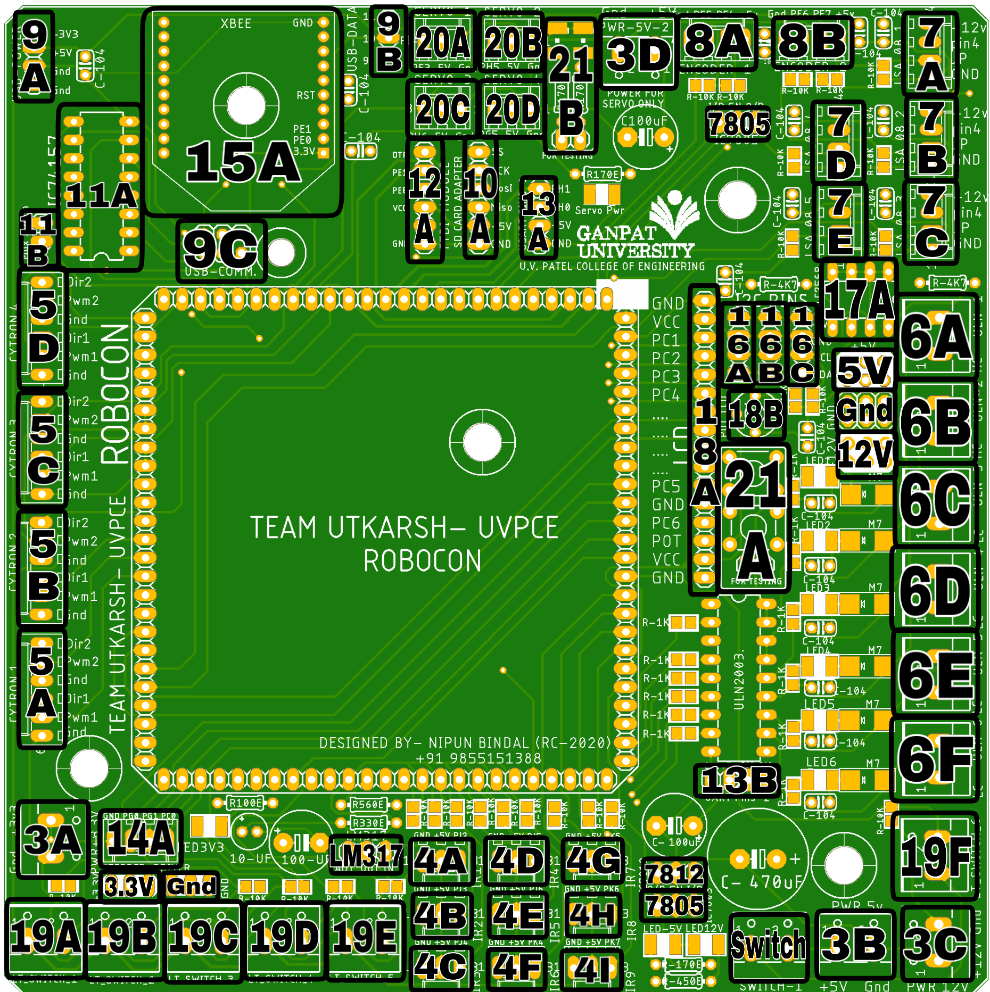

1. **Power Supply**

Theboard contains three different supplies 12V, 5V, 3.3V integrated for specific purposes. Supply 12V at position 3C, and after the switch is closed it regulates 5V and 3.3V respectively to every part of the board where ever required. All three supplies are provided different LED’s each, hence when any of the supply is given the respective LED glows.

An IC7812 is provided in board for protection at low current application therefore if the IC gets heats up because of high current application remove the IC and join the output and input of this IC socket.

In case of heavy current application (more than 1.5A) on 5V, use externally provided 5V sockets (3B) and remove IC7805 (both). Same as in heavy current application of 3.3V use externally provided socket (3A) and remove LM317.

To determine current usage of the bot according to the used devices in the bot refer the table below by multiplying the number of object with the current usage of each device and then adding them all. But always add the current of breakout board and the number of signal pins used for each device even if the device current is already added in the calculations, as the table given is only for current through supply and not for signal pins.

|  |  |
| --- | --- |
| **DEVICE** | **MAX CURRENT (EACH)** |
| Breakout Board | 100mA |
| Signal Pin | 40mA |
| Proximity | 100mA |
| LCD | 20mA |
| MPU 6050 | 5mA |
| Node MCU | 90mA |
| VL53L0x Ranging Sensor | 20mA |
| FTDI Module | 50mA |
| HC-05 | 30mA |

**Other devices do not take current directly from 7805 IC but do take signal current from breakout board.

1. **Proximity Sensors**

There are total 9 proximity sensors provided in the board positioning from 4A to 4I each socket has three pins as Gnd- 5V- PCINT . Every socket has its own respective PCINT pin as per described in the pin out table. PCINT pins are by default pulled up to 5V using 10K resistors.

1. **Motor Drivers**

There are total 4 Motor Driver sockets positioning from 5A to 5D. Each socket has 6pins as DIR2-PWM2-GND-DIR1-PWM1-GND. Which could respectively drive 8 motors at a time if used Cytron MDD-10A drivers or some other similar motor driver which uses 1PWM and 1DIR pin for each motor, but in case of drivers like BTS7960 which use 2PWM and 2DIR pins for each motor 4 motors can be controlled at a time.

The sockets provided are made convenient for all general motor drivers therefore to fulfil all the needs of each and every motor driver a total of 6 pins are provided in each socket, hence use the required number of pins for using the motor driver and just ignore the pins which are not needed for your driver. For example

* For Cytron MDD-10A ignore pin3 (Gnd) while preparing the Molex for your driver and use the rest 5 pins.
* For Cytron MDD-30A prepare each molex for two motor drivers on single socket as each driver requires 3 pins (PWM, DIR, Gnd) and our socket has 2 pairs of them.
* For BTS7960

1. **DCV Switches**

There are total 6 DCV sockets in the board positioning from 6A to 6F. they act as a switch for 12V supply as whenever the pins are set HIGH the socket gets 12V supply, using IC ULN2803, it also has protection circuits made on the board for example for the back EMF generated. It has an indication LED for Each socket which Glows when the DCV is activated. In addition to all this socket 1(6A) and socket 2(6B) can be used for high current application also.

1. **LSA-08 (Line Following Sensor)**

There are total 5 sockets for Line Following Sensors LSA-08 positioning from 7A to 7E which have 4 Pins each ie. 12V-Analog-INT-GND (LSA: Pin9-Pin4- Pin5- Pin10) hence connect the molex accordingly. Here junction pins are by default pulled down to ground. But due to less number of INT pins for Junction of LSA sensors, the INT pins of 7A, 7B, 7C are shorted to those of rotary encoders, therefore prefer them only when rotary encode is not in use. The maximum possible combinations are-

* Use both Rotary encoders and 2 LSA08: 8A+8B+7D+7E
* Use 1 rotary encoder and 3 LSA08: 8A+7C+7D+7E
* Use all 5 LSA08: 7A+7B+7C+7D+7E

LSA08 can be calibrated physically or by programming, but for calibration using programming it requires USART pins hence if required used the provided USART Sockets.

1. **Rotary Encoders**

There are total 2 sockets for rotary encoders positioned as 8A& 8B which have 4Pins each ie. GND-INT1-INT2-5V. Here INT1 & INT2 are pulled down to ground. But these both pins are shorted to INT for LSA08 as mentioned above hence use them accordingly.

1. **USB Host Shield**

There are 3 different sockets on the board placed at positions 9A, 9B& 9C. These all will be used for connecting one USB host Shield on the board. But while connecting the shield do match all the pins on the board to the pins on the shield as only the required pins of the shield are placed on the board. Therefore for fitting the shield on the board a mounting hole is provided on the board specially for the shield near to the ICSP socket.

General instructions for USB Host Shield-

* The required pins to activate the shield are- ICSP socket, 5V,GND, 3.3V & any one DIR pin (Generally PB4 is used).
* Sometimes their might occur a problem during the Uploading of programme on the board, thereby remove the host shield once and then try uploading it.

NOTE: MUST READ THE DETAILS OF 74157 MUX.

1. **Micro SD-Card Adapter**

There is one socket for Micro SD Card on the board positioned as 10A. This socket has 6 pins ie. SS (PC7)-SCK-MOSI-MISO-5V-GND. Use the socket for using SD card to increase the EEPROM of the controller board. This socket uses serial communication hence this socket can be used for any other devices that also use serial communication. Using Micro SD card is least recommended as its substitute is given by EEPROM IC24LC256.

NOTE: MUST READ THE DETAILS OF 74157 MUX.

1. **74157 MUX**

We have only one serial Communication port in our Micro-controller hence to use it for USB host shield as well as SD card adapter we have set up a MUX 74157 at position 11A between the serial communication pins, which is a set of four 2:1 Mux with one Select pin between them. This Mux can be controlled both physically as well as using programme. To control it physically there is a 2 pin socket at position 11B here one pin is connected to select pin of the Mux and the other pin is connected to 5V hence by default the pin set LOW but to change the state of the Mux just short both the pins with each other which will make the pin HIGH hence by this we can keep on changing the state as HIGH or LOW. Also to control it using programme we just need to change the pin PA7 as HIGH or LOW according to the requirement.

* If the select pin is set HIGH, USB host shield will be activated.
* If the select pin is set LOW, Micro SD Card will be activated.

1. **FTDI Module**

There is one socket for FTDI module positioned at 12A, which has 6 pins ie. Reset-RX-TX-5V-Null-GND. Here the null pin is left empty and the RX and TX are at PE1 and PE0 respectively. But the FTDI module as well as X-bee both require default USART pin ie. PE0 & PE1. So use only one of both the devices. As this socket is USART enabled so in case FTDI module and X- bee are not in use we can use the socket for any USART communication also.

1. **USART Socket**

There are 2 USART sockets in the board positioned at 13A&13B, each socket has 4 pins ie. TX-RX-5V-GND. These can be used for any general USART communicating devices like LiDAR. Also for auto calibrating LSA08 sensor using programming we can use these sockets.

1. **Stepper Driver**

There is one stepper motor driver socket in the board positioned at 14A. It has 4 pins ie. GND-DIR1-DIR2-DIR3. These pins will be connected to the stepper motor driver TB6600 as per the following diagram.

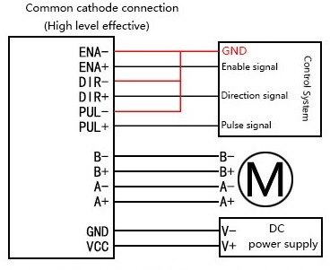

1. **X-bee**

There is one proper socket in the board for X-bee module positioned at 15A. This module uses serial communication as discussed above. Use the module carefully whenever required. It requires TX, RX, 3.3V, GND& Reset pins for their functioning.

1. **I2C Socket**

There are total 3 sockets for modules that use I2C communication positioned at 16A, 16B& 16C. These sockets have 4 pins each ie. 5V-GND-SCL-SDA. Here both the SCL & SDA are pulled down to GND. These sockets are shorted internally hence we need to assign the address to each module for using them also the IC24LC256 uses I2C communication hence if using the IC assign address to it also.

1. **EEPROM IC24LC256**

This IC is positioned at 17A on the board. This IC is used to increase the EEPROM of the microcontroller by 256 KB. It is mainly used whenever mapping of the track is required using rotary Encoders or the programme is lengthy and consumes more EEPROM than 4KB. This IC works through I2C communication and is provided 5V supply.

1. **LCD**

There is a 16 pin Socket for LCD in the boars positioned at 18A, which can activate LCD connected to it but keeping in mind the correct position of the LCD. This socket also has a Potentiometer connected to pin 14, positioned at 18B. This potentiometer changes the contrast of the screen. If the LCD is not in use we can use the socket for getting 6 digital pins from the socket.

1. **Limit Switch**

There are total 6 sockets for limit switches in the board positioned from 19A to 19F. Each socket has 2 pins (5V-PCINT) and will give signal HIGH whenever both the pins of each socket are connected to each other hence after the limit switch is connected the socket, whenever the switch will pressed a HIGH signal will be sent to the microcontroller. By default the PCINT pins are pulled down to ground using 10K resistors.

1. **Servo**

There are total 4 servo sockets in this board positioned from 20A to20D. These sockets have 3 pins each ie. PWM-5V-GND. Each servo consumes high current hence the 5V here provided is totally separated from that of the power provide to other devices therefore to use servo motors provide 5V power to the socket positioned at 3D. After the power is given an indication LED will also glow. So the servos will only work if the LED is glowing.

1. **Testing Circuits**

There are total 2 types of testing Circuits provided in the board positioned at 21A & 21B. Each type of circuit has further 2 testing sockets. These sockets are-

The socket positioned at 21A tests any of the pin on microcontroller by providing the pin HIGH signal. To use this just connect any jumper cable from the pin to be tested to the socket pin of this circuit and press the consecutive push button, for the time push button will be pressed the pin to be tested will remain HIGH.

The socket positioned at 21B tests if any of the pin on the microcontroller is getting HIGH or not. To use this just connect any jumper cable from the pin to be tested to the socket pin of this circuit and if the consecutive LED glows the pin is getting high.